**How to ‘Self-Enrol’ on LEARN for the Informatics Teaching Support Essentials Sessions**

**Instructions**

1. Login to [Learn](http://learn.ed.ac.uk)
2. Select the Self-Enrol tab in the top right of the screen
3. Select ‘Browse course Catalogue’ in the *Course Catalogue (self-enrol courses)* panel

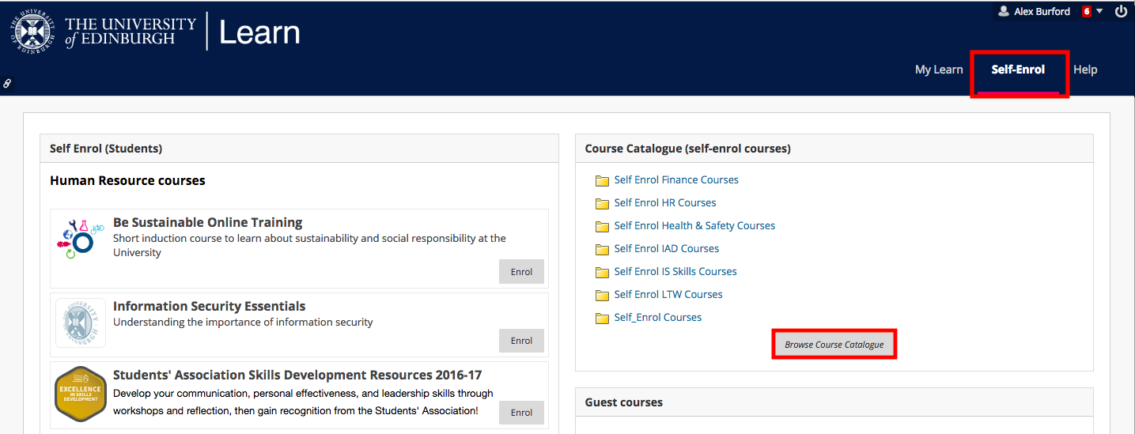

1. In the search bar, type **Informatics Teaching Support** and select ‘Go’.
2. You will see the course listed below. Select the drop-down arrow next to the course ID and select ‘Enrol’.

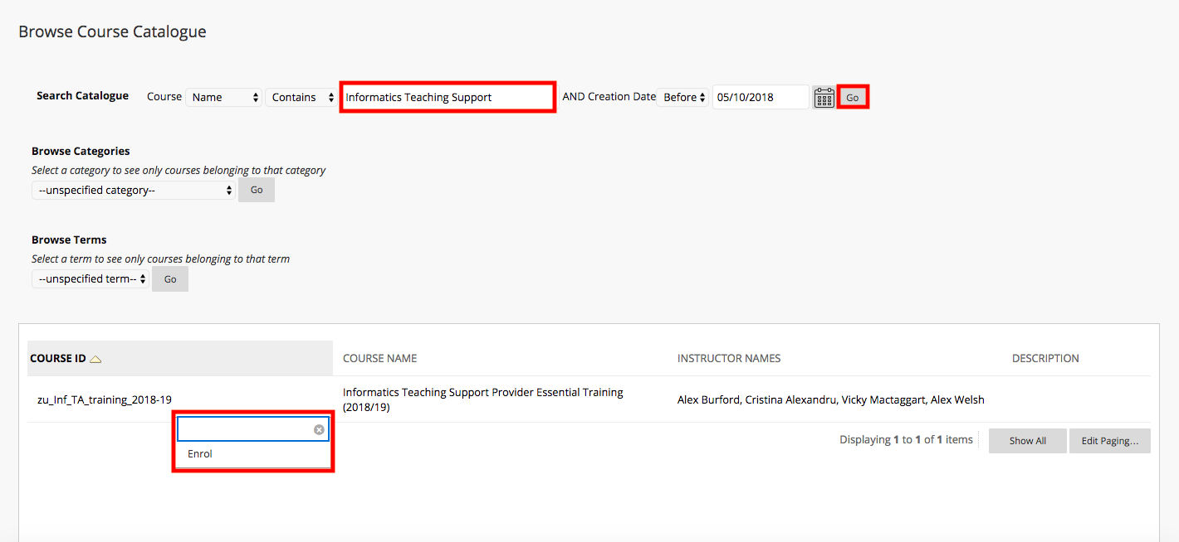

1. The course will now appear in your ‘My courses’ panel on the Learn homepage.