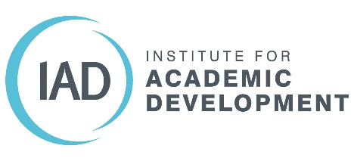

Remote vivas- some additional advice for students
If you are going to undertake your viva remotely, you may feel even more worried about this prospect than if it were face to face. The first thing to remember is that almost all of the advice given for preparing and going through a face-to-face viva is also applicable for remote vivas.
- Preparation
Preparation for your viva is key. There is lots of useful advice about how to prepare for your viva online. A lot of it is summarised in the IAD guide to preparing for the viva (at the bottom of this page): https://www.ed.ac.uk/institute-academic-development/postgraduate/doctoral/advice-support/writing-up
Take time in advance to make sure your computer is set up properly. Test out settings with friends or family members to make sure this is not an added stress on the day.
Mock vivas can also be very useful and so talk to your supervisor about having a virtual mock viva. This will allow you to make sure you are familiar with the technology as well as practicing formulating answers to questions.
- During the viva
Again, much of the same advice can be followed. Try to relax, take your time and ask examiners to repeat questions if you need more clarity or have not heard the full question. Make sure you have some water handy.
One difference online is that it may be more difficult to pick up on facial expressions or other body language. Try not to focus on this, in an examination situation it is often quite difficult to read such cues even if face to face. Instead, think about your material and talking about your research.
Some useful sites and links:
Viva Survivor: http://viva-survivors.com/ and follow on twitter @VivaSurvivors

